**Experiment No. 3.1**

**Student Name:** Gaurav Kumar **UID:** 22MCC20177

**Branch:** MCA**–**CCD **Section/Group:** MCD-1/A

**Semester:** III **Date of Performance:** 30th Oct 23

**Subject Name:** CONTAINERIZATION **Subject Code:** 22CAH-742

WITH DOCKER

1. **Aim/Overview of the practical:**
   1. Working with Docker Compose.
2. **Code for practical: (a)**
3. Compose is a tool for defining and running multi-container Docker applications.
4. If you want to run multi-container Docker applications with one command and simplify the process, we create a docker-compose file.
5. Go to that directory and create a file docker-compose.yml.

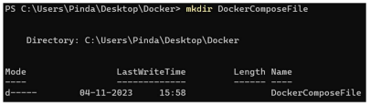

1. Check the validity of docker-compose file.

1. Run docker-compose.yml file.

1. To stop docker-compose.

